

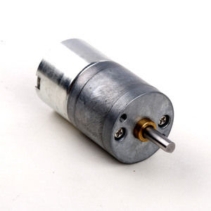

#### LDO-25GM310 Series

**SPECIFICATIONS:**

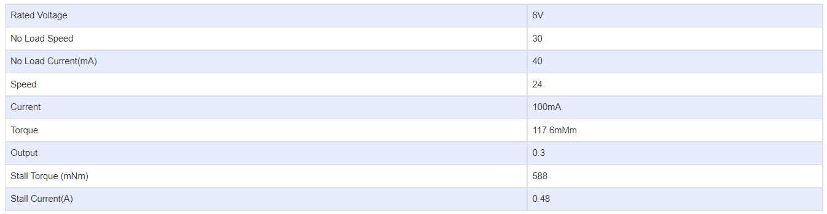

**GEARBOX OPTIONS:**

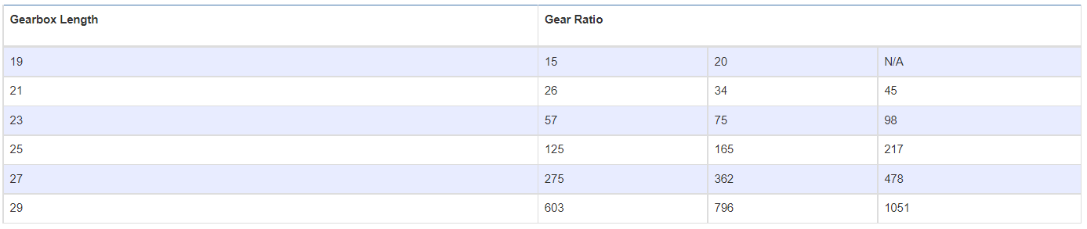

**SUBMODELS:**

*The following are common submodels for the LDO-25GM310 series.*

